TRABUE ROAD OVER SCIOTO RIVER & OVER SCIOTO POINTE DRIVE FRA-CR27-10.77 & 10.89
PID 105759
The Franklin County Engineer’s Office invites you to share your thoughts regarding our upcoming project in your area. We are rehabilitating two bridges on Trabue Road, one over the Scioto River and one over Scioto Pointe Drive. Details about the project are below and a few questions for you to answer are on the second page. If you would prefer, you can go to the Franklin County Engineer’s website and provide comments: http://www.franklincountyengineer.org/public-meetings/

Existing Bridge over Scioto River, 10.77
- Built in 1973
- Condition Rating: 6
(scale: 9 = best, 0 = worst)
- 4 lanes of through traffic, 12-foot wide

Existing Bridge over Scioto Pointe Drive, 10.89
- Built in 1973
- Condition Rating: 7
(scale: 9 = best, 0 = worst)
- 4 lanes of through traffic, 1 turn lane, 12-foot wide

New Bridge over Scioto River, 10.77
- New concrete deck, beams, and supports
- 4 lanes of through traffic, 1 turn lane, 11-foot wide
- 12’-0” shared use path on the north side of the bridge
- 6’-3” sidewalk on the south side of the bridge

New Bridge over Scioto Pointe Drive, 10.89
- New concrete deck, beams, and supports
- 3 lanes of through traffic, 2 turn lanes, 11-foot wide
- 12’-0” shared use path on the north side of the bridge
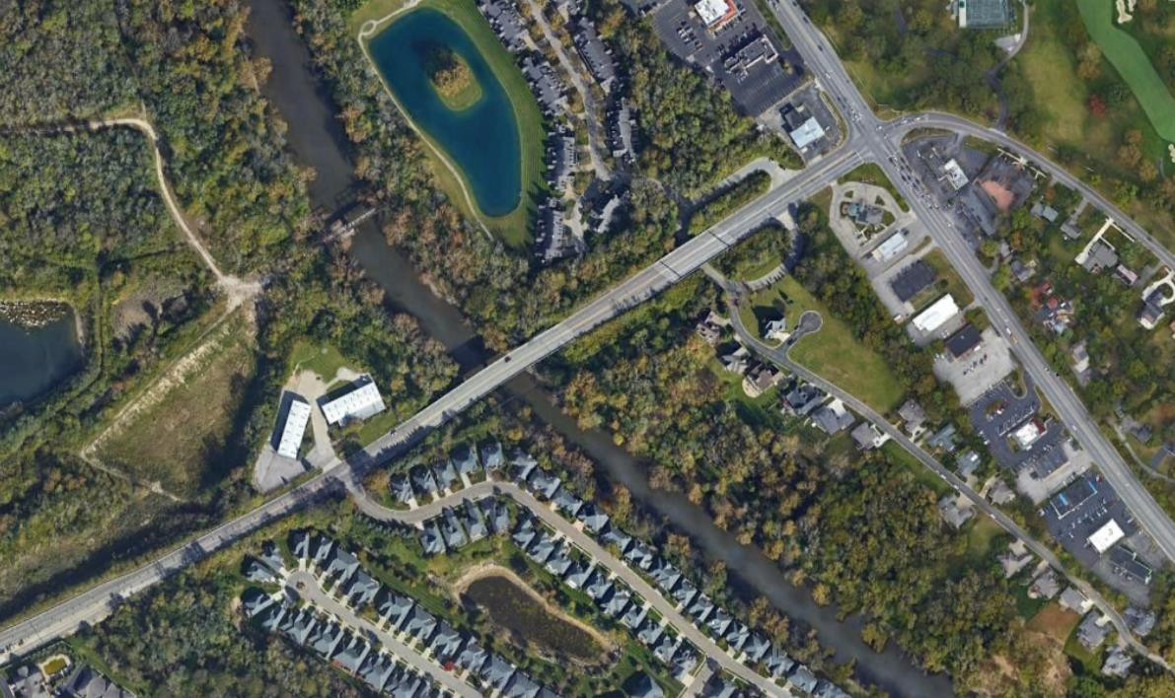


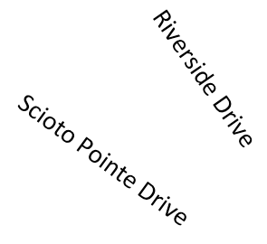
- 6’-3” sidewalk on the south side of the bridge
Trabue Road Bridge FRA-CR27-10.89
Trabue Road Bridge FRA-CR27-10.77
The Quarry & Quarry Trails Metro Park
Location Map
Construction Cost Estimate: $11,276,398

Schedule
- Design Complete: Summer 2023
- Construction Start: Early 2024

Maintenance of Traffic during Construction
- Construction will be completed via a partial road closure, with at least one lane in each direction maintained at all times.
- The anticipated duration is 18 months, starting in Early 2024. This would impact vehicular traffic.

Project Partners
- City of Columbus
- City of Upper Arlington
- Columbus and Franklin County Metro Parks
- Ohio Department of Transportation
- Mid-Ohio Regional Planning Commission
TRABUE ROAD OVER SCIOTO RIVER & OVER SCIOTO POINTE DRIVE
FRA-CR27-10.77 & 10.89
PID 105759
The environmental review, consultation, and other actions required by other applicable Federal environmental laws for this project are being, or have been, carried out by ODOT pursuant to 23 U.S.C. 327 and a Memorandum of Understanding dated December 14, 2020, and executed by FHWA and ODOT

Name: Address:
Email: Phone (optional):

Do you have any concerns with the project? (Please write all responses legibly)

What benefit do you anticipate from the project?

Please provide comments or any concerns you may have about partially closing lanes on the bridge for up to 18 months.

Additional Comments / Concerns:

Please return comments by Saturday, April 15, 2023.

Franklin County Engineer Attn: Kailen Akers, PE 970 Dublin Road
Columbus, OH 43215
Email:
OR kakers@franklincountyengineer.org

